Sprint 2 Planning

# What we got from Steve

## Watching games should work

* This means the back end where games are run has to be up and working.
* Database should be fully fledged so we can properly store games and replay them.
* Focus on the game Tic-Tac-Toe.
  + Steve wants an option to challenge.
  + I am not a fan of it, but I will allow it.
* Stretch goal
  + Steve wants live games working.
* ELO starts at 600.
* Players should be able to add agents.
* Watching games UI example
  + Diagram

    Description automatically generated
* Historical games UI Example
  + 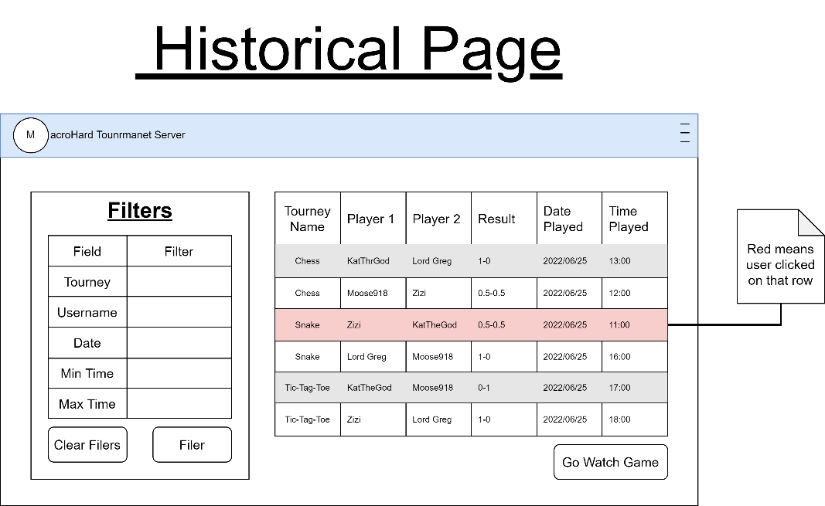

## Make player profile work

* Profile Page
  + Diagram

    Description automatically generated
* Adding New Agents
  + 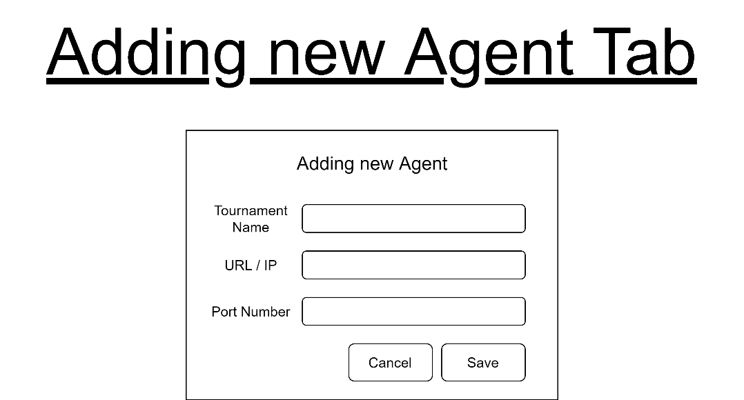

## Clean UI

* Add regular expressions.
* Add more user prompts.
  + When they enter incorrect details for example.
* …

# Additional Goals

## Crete a new Logo

* The current one is fine, but maybe a picture would be nice, like the one we had for INFOs last year.
  + Logo

    Description automatically generated

## Do more with the games.

* Have tournaments running.
* Have more games than Tic-Tag-Toe.
* Have more than 2 players playing in the database.
* Change interface Steve suggested to accommodate for wider range of games.

## Implement custom usernames

* Currently, we have it that a user will have 1 username.
* I was thinking, people can have their main username, then different ones for each agent they have.
* And if they did not set a username for a specific agent, then by default it will be their main username.
* This way if I have my main username:
  + KatTheGod
* And I have 3 agents
  + Chess
  + Snake
  + Gumokku
* I can have different usernames for each
  + Chess
    - My Queen Is King
  + Snake
    - Black Mamba
  + Gumoku
    - 5 star!

## Implement friends / link